**Don’t Worry, Be Happy**

## **Abstract**

The goal of the game is to help Mr. Sadness keep mental health. The depression of Mr. Sadness increases constantly. When the degree of depression reaches the upper limit, the game will be over. Players need to play a match-three game to decrease the depression of Mr. Sadness.

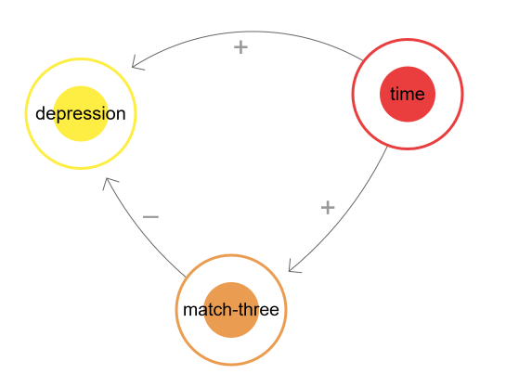

## **Background**

Life can be very tough, especially for Mr. Sadness. He becomes more and more depressed. Player is a self-protect mechanism of Mr. Sadness. Player needs to use good memory to make Mr. Sadness happy.

## **System**

### **Depression**

* The upper limit is 50, the lower limit is 0. Start with 10.
* After the start of the game, depression will increase 1 point per 10 seconds.
* When depression reaches the upper limit, the game is over.
* The time will be the score.

### **Mr. Sadness’s Mind (Match-three)**

* 9*9 square match-three
* When 3 squares which are in the same color are adjacent to each other in the same row or column (“match-three”), the depression minus 1 point. Meanwhile, these squares change color randomly.
* If there are more squares that are adjacent to “match-three” and also have the same color, these squares will also change color randomly. When the number of squares is 4, depression minus 2. When it is 5, depression minus 3. After that, depression minus an extra 1 point for every 2 additional squares.

